**STEEPLE BUMPSTEAD PARISH COUNCIL Meeting @ The Moot Hall, Thursday 12th September 2024 at 7.30pm**

Chair: Kerry Barnes

In attendance: Cllr Borges, Cllr Westrope, Cllr Swaby, Cllr Hexter, Cllr Lacey, Cllr Rust and Cllr Mackenzie

Clerk: Mrs Julia Howard

Also present: Cllr Garrod

Members of the Public: 2

**Minutes**

**24/107 Welcome and to receive apologies for absence -** Peter Hill & Peter Schwier send apologies.

**24/108 Declarations of Interest -**To declare any Disclosable Pecuniary, Pecuniary or non-Pecuniary Interest

relating to items on the agenda

Cllr Hexter - pecuniary interest in relation to planning, will join discussions but not vote, Cllr Rust in relation to planning will abstain, Cllr Mackenzie in relation to quiet lane will involve themselves in the discussion and voting. Cllr Swaby – pecuniary interest in item 24/113, will join discussion.

**24/109 To approve the minutes** (previously circulated) of the Parish Council meeting held on 13th July 2024.

RESOLVED: Proposed by Cllr Mackenzie as a true record, seconded by Cllr Hexter, all in agreement.

**24/110 Question Time** - Public Participation Session with respect to items on the agenda and other matters of mutual interest. Two Members of the public were in attendance. One raised the issue of the Brook maintenance concerns over the volume of vegetation within the brook which is preventing free flow of the Brook. Attempts by the EA in January were not efficient. This item appears on the agenda (24/112)

**24/111 Invitation to Cllr Peter Schwier, Essex County Council and Cllr Diana Garrod, Braintree District**

**Council** to address the meeting on matters of mutual interest.

Cllr Garrod summarised her report (which is on the PC website) and covered a couple of additional items. The SBPC neighbourhood plan is going to panel shortly. September is preparedness month, the nationwide 30days30waysUK campaign has been launched. Planning for Sturmer solar farm was approved; to be built on grade 2 land, it will be in place for 40 years – there are certain conditions within the approval which can be viewed online.

**24/112 Brook management** –significant overgrowth at the brook is concerning residents. A member of the public who has the brook running along their back garden and has an agreement stipulating that the EA would come out to maintain it, is concerned that this hasn’t been happening in recent years.

Clerk to contact EA and report the issue – resident to supply photos and what3words location

Clerk to contact landscapes manager to inspect the flat bank side

Further up towards Church Street, brambles are now growing out and over the pathway on Church Street – Cllr Lacey will attempt to cut it back over the weekend. Add on to next months agenda for an update.

**24/113 Bell ropes Fence / gate / hedge** – update re: safety of the preschoolers using the area **Information**

Cllr Swaby plans to plant a hedge of beech along the inside of the camping close, will dig a trench to plant them in two rows, they aren’t available until October.

The PC will pay for a replacement gate, which is DDA compliant and can be used by wheelchairs and pushchairs.

Chair and Cllr Swaby to do a site visit. Cllr Swaby to contact ECC to chase up about the changes to the definitive map.

Cllr Mackenzie has spoken to SBWEG and they will be putting in some wild flowers along the side where the rope bridge was.

**24/114 Planning**

**Applications**

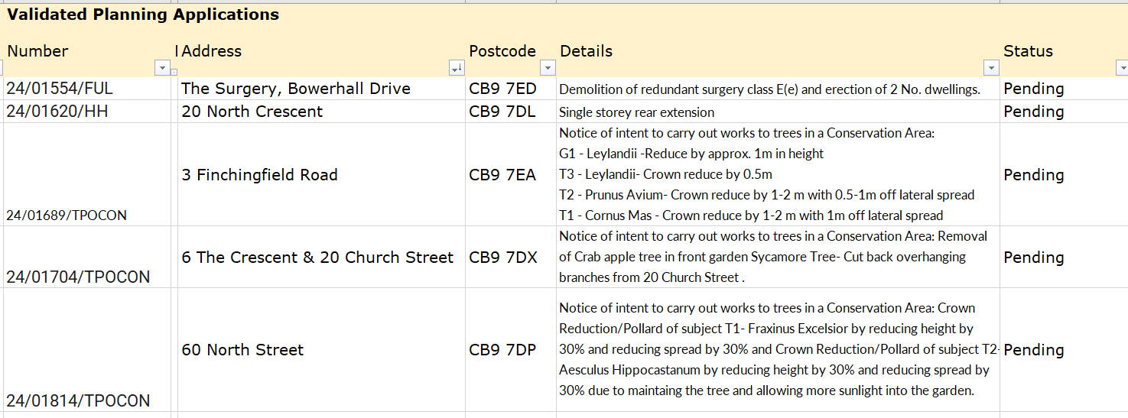

24/01704 – concerns over application being made regarding someone else’s property. Could landscapes/

planning please liaise with both parties – the application mentions 20 Church Street which is a listed property

and has not been consulted. Application should be withdrawn and re-submitted correctly.

**Decisions**

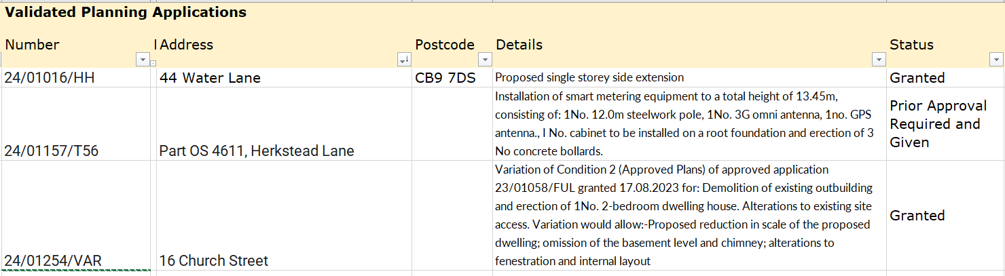

**24/115 BDC Local Plan, incl. Call for Sites and Sustainability assessment** – to provide a summary

and any updates. The PC’s response to call for sites was circulated and briefly spoken about at the meeting. Cllr Westrope raised that there is a brownfield site opposite the garage that he would still like to develop, the PC are in support of this should another application go to planning.

**24/116 Neighbourhood development plan,** to receive an update. We are expecting the final decision from the inspector shortly and then it will have to go to referendum.

**24/117 Financial Matters To note and Decision**

**Item 1.** To note receipts and approve upcoming payments **Decision**

RESOLVED: Proposed by Cllr Lacey, seconded by Cllr Hexter.

**24/118 Admin Information**

**Item 1. Annual Audit –** Closure report received and will be on the noticeboards and website shortly.

Cllr Swaby thanked the clerk for undertaking this successfully again.

**Item 2. Landscapes Tender** – update and timescale. Registration is complete, tender goes online

shortly with an expected start date of January 2025. Applications will go through to a separate email account and won’t be viewed until the closing date. Queries go to the clerk.

**Item 3**. **Handyman vacancy –** now advertised locally. In the meantime, a local odd jobs person has

quoted £85 to sand and treat the map board by the village hall.

RESOLVED: Cllr Swaby proposed, Cllr Hexter seconded this, the clerk will arrange a date for the works to be done.

**Item 4. .gov email addresses** - consideration on change of accounts to a managed email account,

whether as .org or .gov. There is a new push to get all PC’s onto .gov or official email accounts, the PC could consider moving the website to a .gov domain too. and put it into the next years’ budget.

Councillors are in agreement with this, clerk to confirm costs.

**24/119 Quiet Lane** – assessment of the Endway, feedback from parishioners **Decision**

The clerk has had contact from 4 parishioners who are all in favour of the quiet lane, there have been comments that it probably won’t make a difference, others are very favourable.

**24/120 Open Spaces Working group update** – to share status updates on all areas. **Information**

**Item 1.** Open Spaces update, a separate document with updates was circulated to the Councillors. Next OSWG meeting is on 30/09. Cllr Hexter has received enquiries about whether a zip wire will be installed, this is in relation to the voting boxes and surveys done, in relation to the s106 funds. The PC has since found out that the next bit of s106 funds can only be used on sports facilities, therefore if a zip wire is installed the PC will need to find alternative funding options, clerk to find out a cost and insurance impact – follow up in OSWG meeting.

The clothes bin at the Village Hall had been full and people had fly tipped bags of clothing. The dumped bags have been disposed of and the clothing bin has now been emptied. There is a larger clothing bin at the village shop.

**Item 2.** *In*Bloom –2 people responded to the sunflower competition and both won some spring bulbs. Daffodil planting has now been moved to 6th October, 10-12.30, due to a clash at the village hall, approx. 2000 bulbs will be ordered for planting around the village.

**Item 3.** Community Gardens grant – the community herb planter and benches is in place

and needs planting up asap. The grant is available again – we have had it 2 years in a row and think this is

the last year it will run. Closing date is Friday.

Cllr Hexter proposed to apply for the grant tidy up and plant proper Yew trees, remove damaged pots,

seconded by Cllr Rust

Cllr Mackenzie proposed to apply for picnic benches, planter and games bench, seconded by Cllr Hexter

**RESOLVED –** clerk to do 2 application forms as above

**24/121 Water Lane footpath / pavement –** awaiting update from highways. Would like the hedge along the pavement to be trimmed to around 6ft in height.

**24/122** **Churchyard Wall –** update, progress is needed, we are at the point where the funds need to be used as they are affecting the PC’s ability to obtain larger grants and impacting on the plans to use the s106 funds

Chair Cllr Barnes has spoken to a contact at the diocese, who recommended a structural engineer. Chair Cllr Barnes has emailed the structural engineer to provide a price to do a survey of the wall. Chair to meet with the architect.

**24/123** **Closed Churchyard –** foliage and tree management, plus suggestion to plant two yew trees **Decision**

Cllr Hexter Alice has been looking at the state of the churchyard with Matt @treeworx to identify concerns, it was suggested to remove two stump/bushes and replace with two new yew trees (removal ~£1280)

Item moved to next agenda

**24/124 Christmas event meeting** – update on the meeting held on 10th September **Decision**

Cllr Lacey is leading this group and provided an update. The Christmas tree is being donated again by the Bauble Barn – with thanks from the PC. Advent windows will go ahead again. Choirs have been asked to sing. Wooden hanging decorations will be provided to the school and village shop again if both partied are willing. Further updates will come in time.

Resolved. Estimated costs of £100. Next meetings 2nd October, 6th November & 17th November – open to the public.

**O T H E R I T E M S F O R D I S C U S S I O N**

**24/125 Library update –** Alice is looking to resign and the post has been advertised by the Moot Hall

**24/126 North Crescent Play area** – update on progress – have requested an update from Eastlight

**24/127 Digital Switch over –** the end of copper phone lines is imminent, more info on the website

**24/128 Yellow Book –** deadline 13th September

**24/129 Information Sharing –** Cllr Borges - none, Cllr Westrope – none, Cllr Swaby - none, Cllr Hexter - none, Cllr Lacey - none, Cllr Rust - making progress on Village Hall refurbishment, Cllr Mackenzie – none.

**24/130 Meeting Close & Date of Next meeting** – 10th October

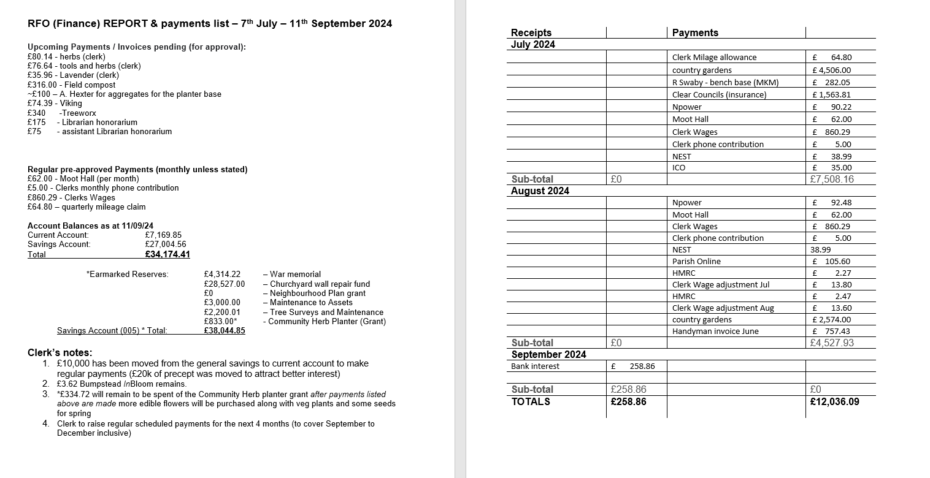

**Signed by Chairman ……………………**

**Date …………………………………………….**