**District Councillor's Report to Parish Councils December 2024**

**Cllr. Diana Garrod - Bumpstead Ward**

**Scheduled Temporary Traffic Regulation Orders & Roadworks**

The closure of the Haverhill Rd, Steeple Bumpstead is scheduled again in early 2025 when Anglian Water intends to continue their next phase. Contact: E: [steeple@anglianwater.co.uk](mailto:steeple@anglianwater.co.uk) or call 03457 145 145 quoting reference number **61886011.**

**Intended closure of Drapers Green, Helions Bumpstead from 2nd December 2024 for 8 days whilst Essex County Council undertakes carriageway patching.**

**Design Code Consultation – Please complete a short questionnaire**

BDC are creating a new Design Code, a planning policy document that aims to set out clear expectations of good quality design principles for the District. Design Codes outline in detail to developers, housebuilders and architects what is required from their proposal plans before they are submitted, guaranteeing standards are upheld and removing the uncertainty which can lead to delays in the planning process.  It covers topics from the natural environment and buildings, to roads and street lighting. The code would be used when determining planning applications to help direct the look and feel of a development and how it should interact with the surrounding area. **The consultation will close at 5pm on Monday 16th December.** This is the first step in a series of consultation events. This initial consultation is quite concise in nature (following central government guidance) and seeks resident's views on the geographical coverage of the code, in addition to some questions around key design topics, developer engagement and gauging the level of desired future public engagement in the Design Code project.

BDC are initially seeking the views of local people, communities and stakeholders to help shape the Design Code. This is to understand what is important to residents when it comes to the design of new developments. Please complete the short questionnaire to answer some questions and express your interest in being involved in future engagement

<https://www.braintree.gov.uk/planning-building-control/design-code>

**Government Consultation: 8 weeks from 24th October 2024**

**Enabling remote attendance and proxy voting at local authority meetings.**

This is a short consultation which seeks views on the detail and practical implications of allowing remote and hybrid attendance and proxy voting at local authority meetings in England. I would encourage parish councillors to provide their views. Link:  [https://www.gov.uk/government/consultations/enabling-remote-attendance-and-proxy-voting-at-local-authority-meetings/enabling-remote-attendance-and-proxy-voting-at-local-authority-meetings](https://gbr01.safelinks.protection.outlook.com/?url=https%3A%2F%2Fwww.gov.uk%2Fgovernment%2Fconsultations%2Fenabling-remote-attendance-and-proxy-voting-at-local-authority-meetings%2Fenabling-remote-attendance-and-proxy-voting-at-local-authority-meetings&data=05%7C02%7Ccllr.dgarrod%40braintree.gov.uk%7C581593d647984be7744e08dcffd4ac0b%7C25f7dc6a2f004c05bf5b651e113d3f16%7C0%7C0%7C638666536107613747%7CUnknown%7CTWFpbGZsb3d8eyJFbXB0eU1hcGkiOnRydWUsIlYiOiIwLjAuMDAwMCIsIlAiOiJXaW4zMiIsIkFOIjoiTWFpbCIsIldUIjoyfQ%3D%3D%7C0%7C%7C%7C&sdata=InkLrkpS45XeD%2Bx5o6faM5HquNSkDiZjDJiBFUAYqFE%3D&reserved=0)

**Rail Fares**

Regulated train fares in England are to increase by 4.6% next year, while the price of most railcards will rise by £5, the government has announced. The increases were not mentioned by the chancellor in her Budget speech but it was instead noted in the Treasury's budget document. The changes will come into force on 2 March 2025.

**Suffolk News: Haverhill Banking Hub – Now Open**

A Banking Hub is a shared banking space on the high street. Hubs offer a counter service operated by the Post Office, where customers of all major banks and building societies can carry out regular cash transactions, Monday to Friday. They also offer a Community Banker service where customers can talk to their own bank about more complicated banking issue on the day their bank is in the Hub.

Unit 1, The Chauntry Centre, High Street, Haverhill. CB9 8AA

<https://www.cashaccess.co.uk/hubs/haverhill-suffolk/>

**Village Halls Week – Save the date**

Village hall groups across the UK are being encouraged to put **17-23 March 2025** in their diaries by Action with Communities in Rural England (ACRE).

The charity hopes to use the week as an opportunity to spotlight the efforts of volunteers who keep these important venues open for the benefit of local residents, groups, and rural businesses.

A facility has been set up on ACRE’s [website](https://acre.org.uk/village-halls-week-2025/) that village hall groups can use to register their interest in the campaign, receive news and updates as well as resources to help them get involved. Thanks to sponsorship from [Utility Aid](https://utility-aid.co.uk/), rural community buildings in both countries are being offered free resources including bunting, badges and posters to help them hold local events and draw attention to their good work.

Info at: <https://rsnonline.org.uk/village-halls-week-2025-save-the-date>

**Local Plan – Call for Sites**

Braintree District Council has received additional proposals for development which are within Bumpstead Ward. Sites will then be considered by the Local Plan Sub Committee in spring 2025, followed by formal public consultation on the sites.

**Sturmer**

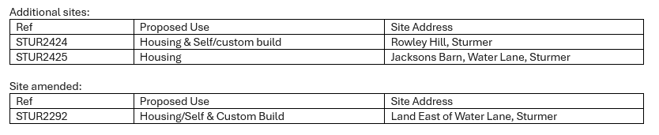

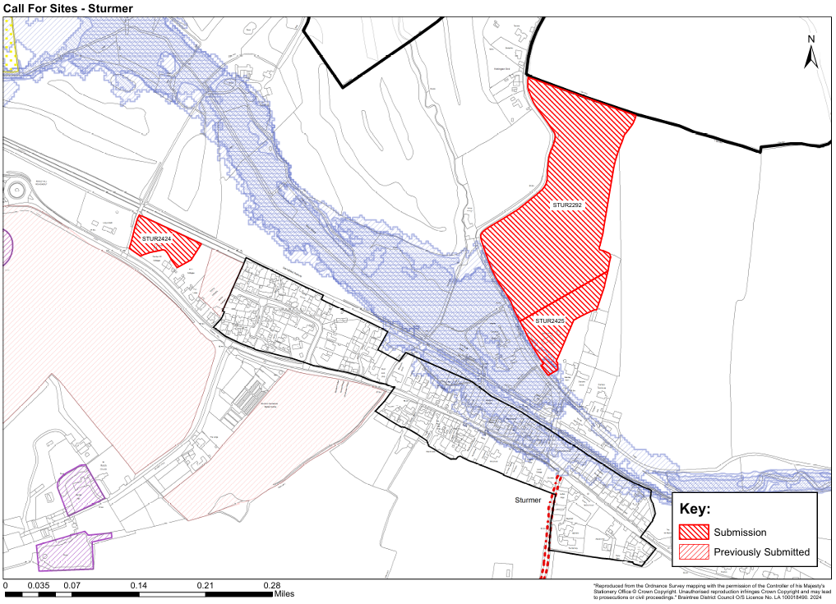

**Birdbrook**

(Summer 2024, Map 1 still awaiting comment from parish council)

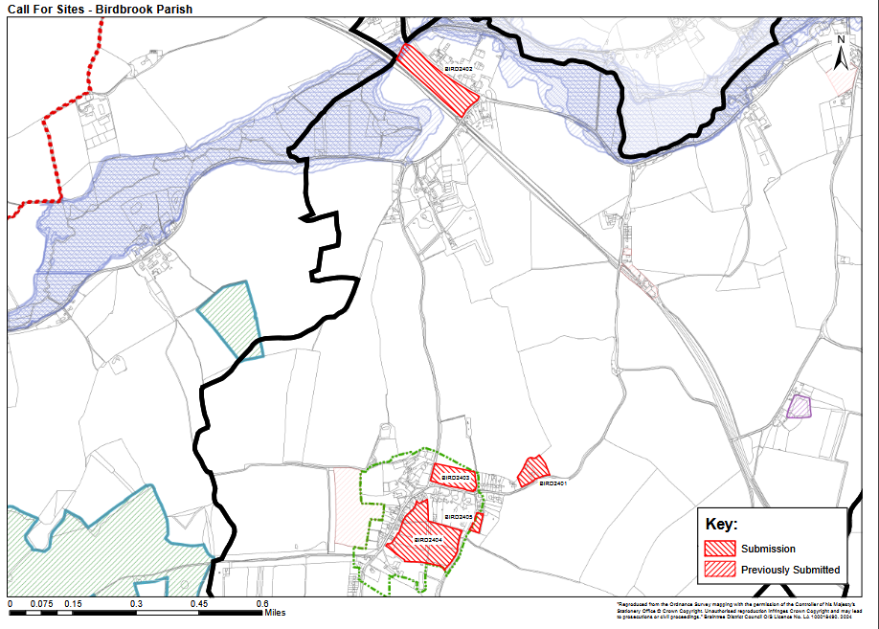

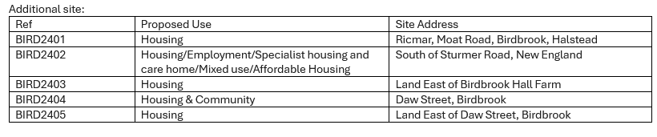

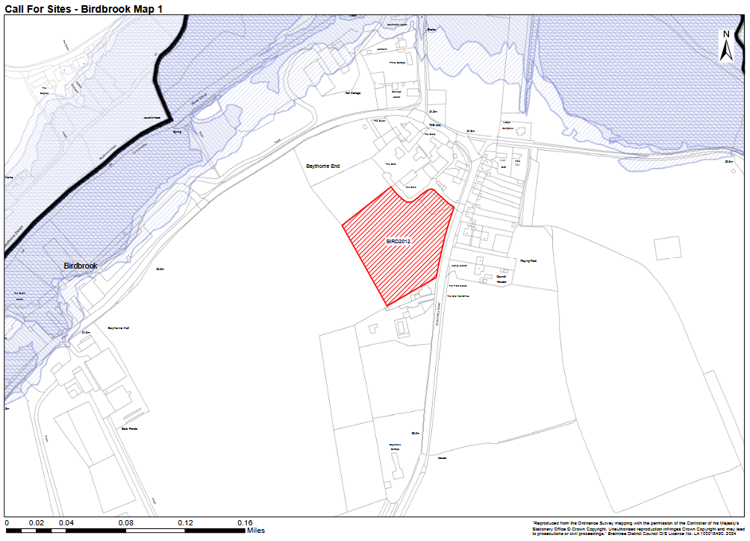

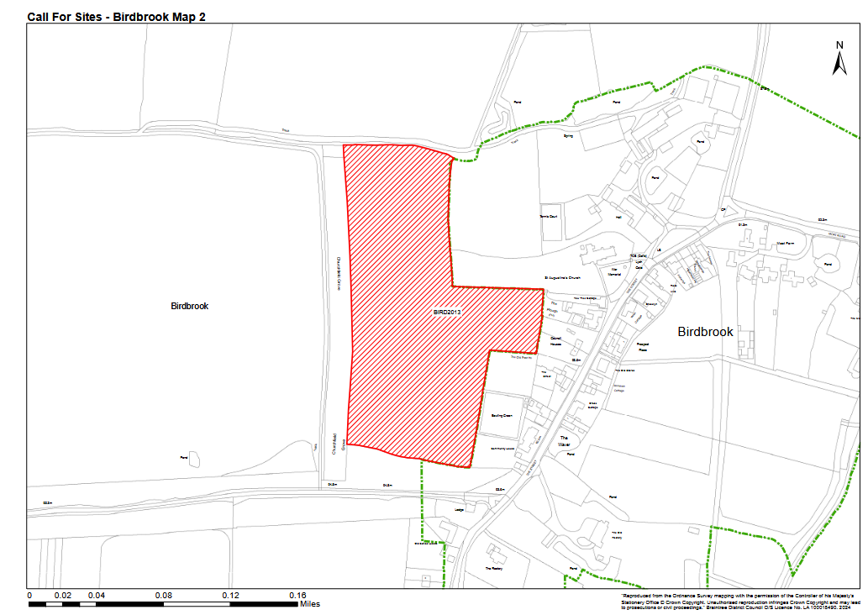

**Steeple Bumpstead**

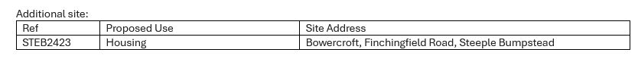

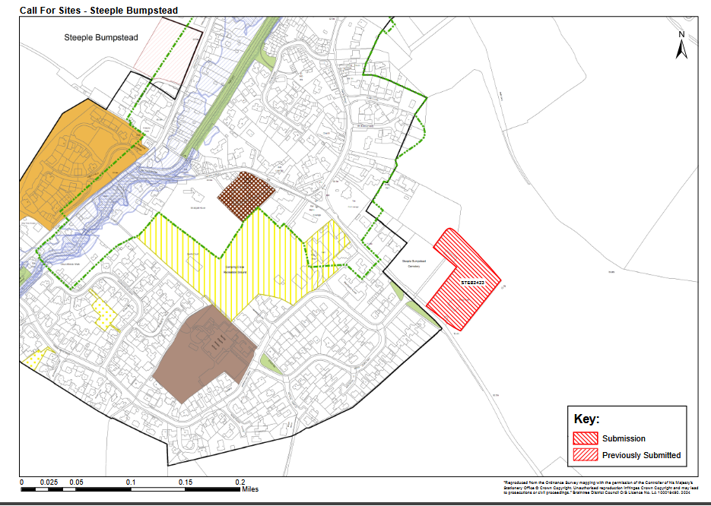

Comments are requested by mid January 2025. All the additional sites will be added to BDC’s existing online Call for Sites Map in the next few weeks: <https://www.braintree.gov.uk/planning-building-control/local-plan-review-2/3>

Please note that as previously, this is very early, informal consultation. There will be several further opportunities to comment throughout the Local Plan review process. The next planned public engagement does not consider specific sites, but will be the Issues and Options Consultation which will look at BDC’s existing document to determine how effective the policies continue to be and how they could be updated. This consultation will take place in January/February 2025.

**Cllr**. Diana Garrod

Braintree District Councillor - Bumpstead Ward