**Members of the Council are hereby summoned to attend the**

**STEEPLE BUMPSTEAD PARISH COUNCIL Meeting @ The Moot Hall**

**ON Thursday 9th January 2025 at 7.30pm for the purpose of transacting the following business.**

**Members of the press and public are welcome to attend.**

Chair: Cllr Kerry Barnes

Present: Cllr Hill, Cllr Westrope, Cllr Borges, Cllr Hexter, Cllr Lacey, Cllr Mackenzie and Cllr Rust

Clerk: Mrs Julia Howard

Members of the public: none

**DRAFT MINUTES**

**25/001 Welcome and to receive apologies for absence -** Apologies received from Cllr Swaby & Cllr Schwier

**25/002 Declarations of Interest** - None **Information**

**25/003 To approve the minutes** (previously circulated) of the Parish Council meeting held on 12th December

2024. - Some of the Councillors considered that the discussion on 24/177 should have been recorded in the minutes

regarding the gifted hedge stopping at the corner of the building and not going beyond, and across the side of the

garage building, the Clerk agreed to note this here, but not alter the minutes as they reflect the decisions made.

RESOLVED Proposed to accept the minutes by Cllr Mackenzie, seconded by Cllr Hexter, all agreed.

**25/004 Question Time** - none **Information**

**25/005 Invitation to Cllr Peter Schwier, Essex County Council and Cllr Diana Garrod Braintree DC**

**Cllr Schwier** attended after another meeting and so the Chair came back to this item after 25/010

the CC council tax element is expected to be around 3.5-4% to be decided in February.

The CC has made efforts with active transport, implementing e-scooters, bike-ability across schools etc.

Still working with Suffolk and Norwich with regard to upgraded pylons across the land.

Working on clearing drains and gulleys in response to requests following recent snow and rainfall / flooding.

The ECC leader is holding an extra ordinary meeting on 10th December re: devolution, this is viewable on the YouTube channel. The chair commented that we are concerned about being lost in the suggested new format.

The PC then returned to 25/011 on the agenda.

**Cllr Garrod** has circulated her report (which is on the PC website) and summarised some key points. There is a waste and recycling survey online for 8 weeks and is proposing 5 bins per household with a collection cycle of 8 weeks, the County Council devolution meeting is tomorrow and available to view online on YouTube.

**25/006 New hedge planted by Bellropes/Tanyard** – an update on the progress of the donated hedge.

The Chair and landowner are creating a written agreement showing the hedge going from the wooden fence across the tree line and alongside the garage building (to be signed once agreed by the PC), once signed, photos will be added and filed on Parish Online as well as the PC’s archive. There will be some legal advice sought in regard to the document. The Council agreed to this; however, Cllr Westrope doesn’t agree, he has concerns primarily around a potential land grab and asked for this to be recorded in the minutes. Document to be signed before the next PC meeting.

**25/007 Anglian water road closures** – an update on the local closures and works **Information**

Cllr Mackenzie has been in liaison with Anglian Water, the works are due to start on Monday 13th January. If there are any changes these will be shared on the PC website, FB page and community FB pages.

**25/008 Planning**

**Applications**

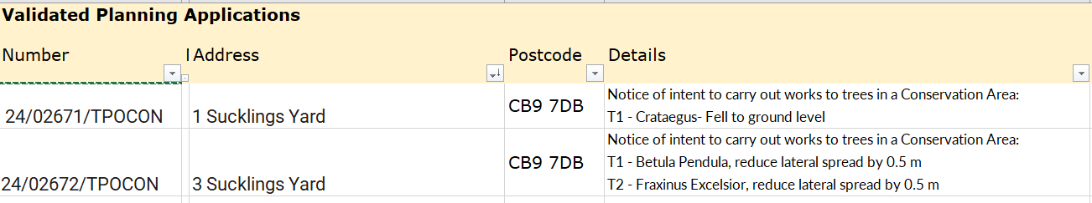

The PC doesn’t typically comment on TPO’s and has no comment on these applications.

**Decisions**



**25/009 Neighbourhood development plan -** The PC is waiting for BDC to move this forward.

**25/010 Financial Matters (appendix 1. Finance report) To note and Decisions**

RESOLVED **Item 1.** To note receipts and approve upcoming payments – the noticeboard payment will not be going ahead as a new supplier is required.

Cllr Hexter proposed to accept the report and upcoming payments, Cllr Rust seconded, all in agreement.

RESOLVED **Item 2.** To approve the proposed budget for 2025/26

The Finance working group met on Monday and worked through the budget and expected future costs, totalling £58,380 expenditure. The PC receives a small amount of income, in the form of VAT claim, Grants and rental.

The proposed budget was shared. The PC asked some questions and then agreed the budget, as recommended by the finance working group.

**Item 3.** To agree the precept figure for 2025/26

RESOLVED A 2.56% increase on the *precept figure for band D* was agreed, which is in line with inflation, totalling £51,700. Cllr Borges proposed, Cllr Hill seconded, resolution was confirmed by voting. Cllr Hexter didn’t vote.

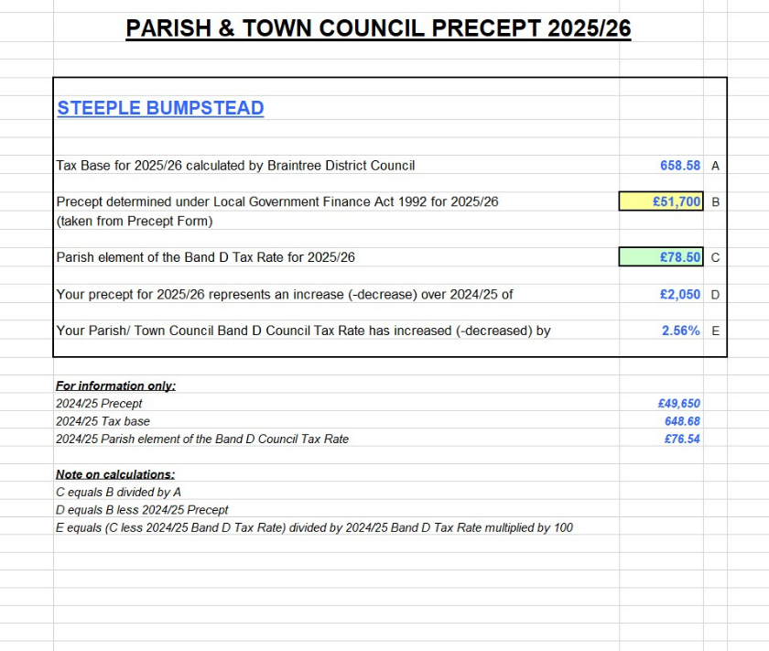

**25/011 Admin Information & Decision**

**Item 1. gov email addresses, website and cyber-security** - Decision on change of accounts

The working group has not resolved this yet.

**Item 2**. **Clerks report –** an update on previous delegated actions was shared with the PC.

**Item 3**. **Grants** - update on applications and grant reports, incl. s106

The PC has not heard about the CIF grant (for zip wire), results were expected by the end of December.

Jack Hubbard has been working with the clerk and the Ninja trail grant is being submitted this month

The CIF grant report for Safer Surface not done yet (Cllr Mackenzie is working on this)

Herb planter grant report is due in next couple of months, there is still some money to be spent. The clerk will do this report.

**25/012 Closed Item – To agree clerk’s hourly rate and pension** – this item is closed to the press & public (who may return afterwards). Following the budget meeting on Monday and the clerk’s appointment with another Parish Council it was agreed to postpone a decision until end of March for April onwards **Decision**

**25/013 War Memorial –** consideration of remedial works required **Decision**

Cllr Westrope has spoken to contractors to get quotes for remedial works to minimise the water issues, including the possibility of installing a soakaway.

**25/014 Flood Initiatives Group** – Cllr Hexter has scheduled the first meeting for 15th January at the Moot Hall, a terms of reference has been drafted. This is not solely focussed on the Endway, but throughout the village. Including maintenance of ditches, and emergency plans.

**25/015 Open Spaces Working group update** – to share status updates on all areas. **Information**

OSWG, the broken bench has been repaired. Nothing further to report, will need to spend some time on the OS action plan.

Footpaths: 29 was blocked by Heras fencing, Cllr Rust has rectified this. Footpath 33 obstructions noted in item 25/06 above, awaiting ECC diversion decision.

North Crescent Play Equipment to be officially opened on 27/1/25, the ground is quite uneven in places.

**25/016 Events** – update on recent and forthcoming events

Cllr Lacey is to call a review of Xmas 2024 for next week, date & time tbc

Cllr Rust to kick off the plans for village showcase (clerk to send save the date email to previous attendees and put a note in the Yellow Book)

Cllr Mackenzie working on Bumpstead Day, first meeting 27/1/25

VE80 May 8th plans still undecided

**O T H E R I T E M S F O R D I S C U S S I O N**

**25/017 Yellow Book deadline** – 17th January 25, Cllr Hexter will draft the article.

**25/018 Information Sharing –** Cllr Hill – Fido bin at Bellropes was out of use Richard Bass BDC has been contacted, Cllr Westrope – none, Cllr Borges – none, Cllr Hexter – chippings tipped at end of Riverside walk (Claywall bridge) these haven’t been moved for the pathways and are looking like a compost heap Cllr Mackenzie to speak to SBWEG, Cllr Lacey – none, Cllr Mackenzie – increase of McDonalds litter has been found on the roadside and will be taken back to them as action may be taken, Cllr Rust – pre-school has closed, but the toddler group will resume on Tuesdays at the end of the month. Village hall refurbishment is well underway, the Defib has temporarily been removed and will be updated and put back up.

**25/019 Meeting Close & Date of Next meeting** – 13th February, meeting closed 21.34

**Appendix 1. Finance report**

