**Members of the Council are hereby summoned to attend the**

**STEEPLE BUMPSTEAD PARISH COUNCIL Meeting @ The Moot Hall**

**ON Thursday 13th March 2025 at 7.30pm for the purpose of transacting the following business.**

**Members of the press and public are welcome to attend.**

7th March 2025

Julia Howard, Clerk to Steeple Bumpstead Parish Council

**A G E N D A**

**25/042 Welcome and to receive apologies for absence Chairman**

**25/043 Declarations of Interest Information**

To declare any Disclosable Pecuniary, Pecuniary or non-Pecuniary Interest relating to items on the agenda

**25/044 To approve the minutes** (previously circulated) **Decision**

of the Parish Council meeting held on 13th February 2025.

**25/045 Question Time** **Information**

Public Participation Session with respect to items on the agenda and other matters of mutual interest. Please note: The maximum time allowed for this item is 15 minutes but may be extended at the discretion of the Chairman

**25/046 Invitation to Cllr Peter Schwier, Essex County Council and Information**

**Cllr Diana Garrod, Braintree District Council** to address the meeting on matters of mutual interest.

**25/047 Anglian water road closures** – an update on the local closures and works **Information**

**25/048 Planning**

**Applications -**

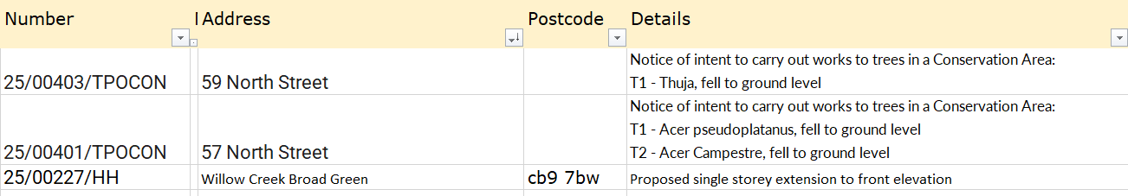

**Decisions –**



**25/049 Neighbourhood development plan,** to receive an update **Information**

Steeple Bumpstead Neighbourhood plan Referendum is on 3rd April 2025.

**25/050 Financial Matters To note and Decisions**

**Item 1.** To note receipts and approve upcoming payments

**25/051 Admin Information & Decision**

**Item 1. Policies –** to adopt donation, gifts and hospitality policy **Decision**

**Item 2. Annual Audit**

**Item 3**. **Clerks report –** an update on previous delegated actions

**Item 4**. **Grants** - update on applications and grant reports, incl. s106 & National Lottery

**25/052 Events** –VE80 and Village Showcase progress / proposals **Decision**

**O T H E R I T E M S F O R D I S C U S S I O N**

**25/053 Yellow Book deadline** – 14th March

**25/054 Amphibian Study at Bellropes** – information on proposed local study.

**25/055 Information Sharing**

**25/056 Meeting Close & Date of Next meeting** – Annual Parish Meting 26th April, PC meeting 8th May