**STEEPLE BUMPSTEAD PARISH COUNCIL Meeting. The Moot Hall, Thursday 12th December 2024**

Chair: Cllr Barnes

In attendance: Cllr Mackenzie, Cllr Rust, Cllr Borges, Cllr Lacey, Cllr Westrope, Cllr Hexter and Cllr Hill

Clerk: Mrs Julia Howard

Members of the public: Five

**MINUTES**

**24/171 Welcome and apologies for absence -** Cllr Swaby, Cllr Schwier and Cllr Garrod send apologies.

**24/172 Declarations of Interest -** none

**24/173 To approve the minutes** - of the Parish Council meeting held on 14th November 2024.

RESOLVED Proposed as a true record by Cllr Mackenzie, seconded by Cllr Lacey, all in agreement.

**24/174 Question Time** One member of the public spoke about reform and local politics and introduce two others. They were reminded that the PC is a non-political body.

**24/175 Invitation to Cllr Peter Schwier, Essex County Council & Cllr Diana Garrod, Braintree District**

**Council** to address the meeting on matters of mutual interest. The Chair asked Councillors to refer to reports already

received.

**24/176 Village Library Update** –update from the new Librarians. The Chair *suspended the Standing Orders* to allow the two new librarians to introduce themselves and their plans for the library. 300 new books being delivered. Have contacted local village groups and trying to get them involved in using the library. The library now opens twice a week. Currently has 7 volunteers and are working to increase footfall. Have enquired about grants available for the library. *Standing orders were then resumed.*

**24/177 New hedge planted by Bellropes** – an update on the progress of the donated hedge **Information**

A temporary fence has been put in and a hedge is being planted on the camping close and gifted to the PC, who will maintain it. Chair Barnes will be liaising with the landowner. A formal agreement will be created and stored on our Parish Online account, particularly in regard to removing the fence and maintaining the hedge.

**24/178 Landscapes Tender** – to hear the results of the interviews and appoint a contractor **Decision**

RESOLVED Following a formal process, the landscapes group proposed that the successful applicant of the tender is Zion Landscapes Ltd, subject to references, site visit, due diligence and contract. Chair Barnes made the proposal, seconded by Cllr Hexter, all agreed.

**24/179 Planning**

**Applications**

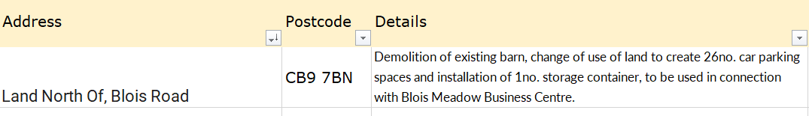

No objection as it is within accepted developments for this type of site.

**Decisions**

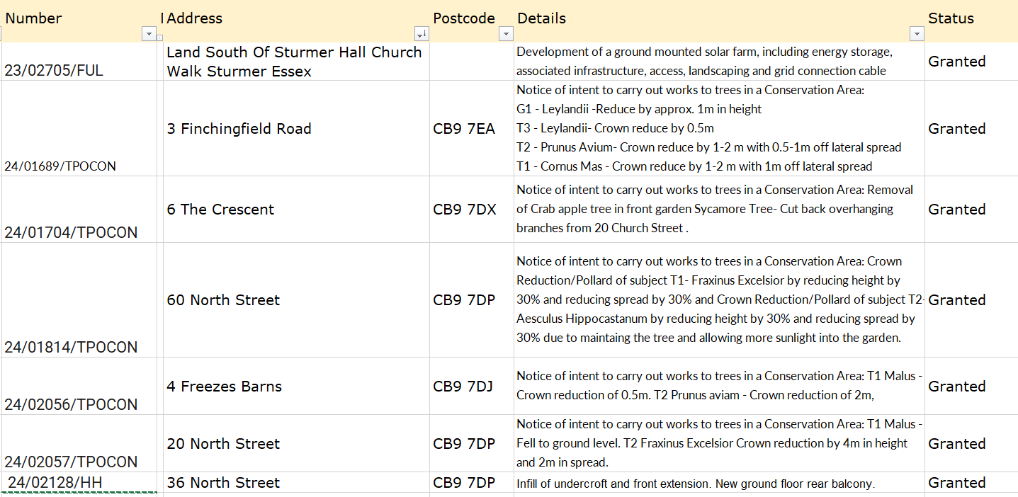

**24/180 Call for Sites, additional submissions** **Information**

**STEB2423** – The PC comment that this site is outside of the village envelope and not in accordance with our emerging neighbourhood plan and has no benefit to the village.

**24/181 Neighbourhood development plan,** to receive an update. Waiting for BDC to arrange a referendum.

**24/182 Financial Matters To note and Decision**

**Item 1.** To note receipts and approve upcoming payments **Decision**

RESOLVED- Cllr Hexter proposed to accept the payment report, Cllr Westrope seconded the motion.

**24/183 Admin Information & Decision**

**Item 1. Emergency plan** – updated for 2024-25 and submitted to BDC for confirmation

**Item 2**. **gov email addresses, website and cyber-security** – working group hasn’t met yet, however

85% of the .gov grant has already gone. Clerk and Cllr Lacey are booked onto a .gov info session on 18/12

**Item 3**. **Grants** - update on applications and grant reports, incl. s106. CIF grant result hasn’t been

received yet, the previous CIF grant report is due, Cllr Mackenzie is doing this. The s106 grant meeting with a supplier was postponed. Clerk to chase up a new date.

**24/184 Closed Item – Personnel matters** – this item is closed to the press & public (who may return afterwards) – The Chair did not close the meeting for this item and advised it is deferred to next month **Decision**

**24/185 War Memorial –** consideration of remedial works required; the paving requires re-pointing. A gully at the edge of the war memorial path would reduce water ingress. Cllr Westrope to obtain costs and may undertake works up to £500, anything over £3,500 will require 2 quotes as per financial policy and agreement **Decision**

**24/186 Flood Initiatives Group** – update as we come into the wet season again. The Endway will be closed in the next set of Anglian Water maintenance works (starting from 6th Jan) which will have a significant impact on the routes in and out of the village. Cllr Hexter is arranging a meeting for the FIG group and will be focussed on ensuring roads are passable. **Information**

**24/187 Open Spaces Working group update** – no updates for PROW or OSWG however the North Crescent play area re-build is well underway and due to open mid-January **Information**

**24/188 Events** – update on recent and forthcoming events **Decision**

The Christmas Tree lighting event was really busy and popular. It was moved into the village hall due to poor weather but was warmly received. A review meeting will be held in January 2025.

Bumpstead Biennial day development is looking good, the first meeting will be in January 2025.

VE80th Anniversary Thursday 8th May 2025 – national plans include a beacon event across the country. Looking to do this in the village and a gathering at the War Memorial. Consider whether beacon grants are available.

Village Showcase / Parish Meeting – booked for 26th April at the Village Hall, due to start at 3pm, along the

same lines as the 2024 Showcase. Working Group to pull this together, Cllr Rust leading plus Cllr Mackenzie,

Cllr Hexter and Cllr Lacey. Details to be arranged by email rather than meetings.

**O T H E R I T E M S F O R D I S C U S S I O N**

**24/189 Twenty’s Plenty** – update re: speed reduction on Bower Hall Drive & Church Street.

No update this month.

**24/190 Anglian Water** – water saving packs available, the clerk has requested 150 water saving shower heads and 100 bath buoys. Cllr Hexter will arrange a time for them to be collected by members of the village.

**24/191 Information Sharing –** Chair - a reminder to provide documents to the clerk 7 clear days prior to the meeting, along with supporting documentation, Cllr Hill – none, Cllr Mackenzie – has made arrangements to dispose of the village Christmas tree, Cllr Rust – Pre-school is closing before Christmas and will sadly not re-open, the toddler group will continue. The Village Hall refurb starts in the new year, in stages. Cllr Borges – there is mud on road towards Haverhill which has made road conditions very dangerous. Adam Haylock is the farmer who may need to be informed, Cllr Lacey – none, Cllr Westrope – none, Cllr Hexter – None.

**24/192 Meeting Close & Date of Next meeting** – Next meeting is 9th January, meeting closed at 21.11

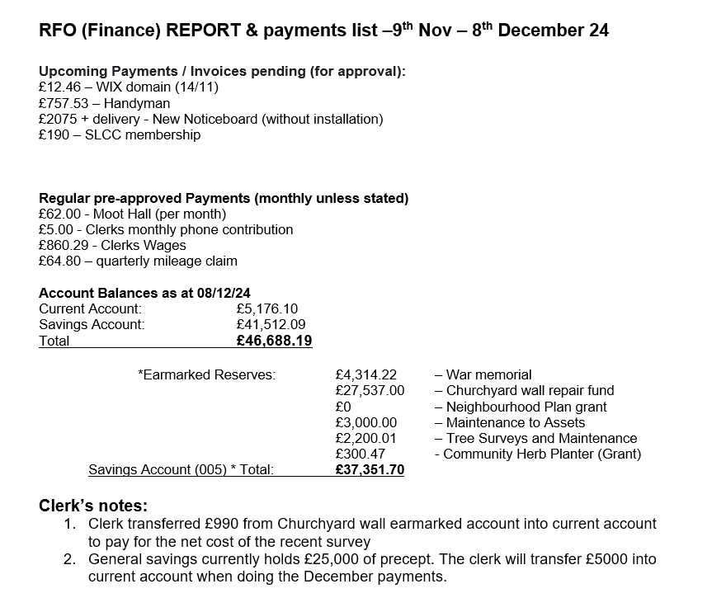

**Signed by Chairman ……………………**

**Date …………………………………………….**