**STEEPLE BUMPSTEAD PARISH COUNCIL Meeting @ The Moot Hall, Thursday 10th October 2024 at 7.30pm**

**In attendance: Cllr Westrope, Cllr Borges, Cllr Swaby, Cllr Hexter, Cllr Mackenzie, Cllr Rust, Cllr Lacey and Cllr Hill**

**Also in attendance: Cllr Garrod**

**Clerk: Mrs Julia Howard**

**Members of the public: one**

**MINUTES**

**24/131 Welcome and to receive apologies for absence -** Apologies received from Cllr Peter Schwier

**24/132 Declarations of Interest - none**

**24/133 To approve the minutes** (previously circulated) of the Parish Council meeting held on 12th

RESOLVED Sept. 2024. Proposed as a true record by Cllr Westrope, seconded Cllr Mackenzie, all in agreement.

**24/134 Question Time** Public Participation Session **Information**

A Member of the public raised concerns over the next stage of the Anglian Water repair works and the impact this would have on access through and around the village. Will this also delay the progress of the quiet lane at the Endway. Cllr Mackenzie is the Liaison with Anglian water and provided a brief update. Phase 1 will finish 25/10 and then all works will stop until the new year, phase 2 is being re-evaluated. Update next month.

Although not in attendance, a MOP has asked whether there has been consideration of a 20mph speed limit on Bower Hall Drive, on the section near the school and camping close, this was looked at around 6 years ago however there was a resistance from the community with regard to additional illuminated signage. Cllr Lacey will progress this for Bower Hall drive and Church Street and provide an update next month.

**24/135 Invitation to Cllr Peter Schwier, Essex County Council and Cllr Diana Garrod, Braintree District**

**Council** to address the meeting on matters of mutual interest. Cllr Garrod briefly summarised her monthly report

which is on the PC’s website. Including simpler recycling, the Anglian water update, bikeability in Braintree during

half term. Community Police attended St Mary’s Church today for a dedicated regular event.

Clerk to send an email to McDonald’s customer services to ask what measures they have for the litter, we are seeing

increasing litter in our parish.

**24/136 New Handyman** –following interviews on 30th September the Personnel Group would like to appoint

3 hours at SCP2 rates. Proposed by Cllr Hexter seconded by Cllr Swaby.

RESOLVED **Decision**

**24/137 Zip Wire-** following interest from the public, the PC are asked to consider funding options

The OSWG have been asked several times by parishioners whether there will be a zip wire. Therefore, 3 quotes have been obtained between £10k and £15k (including Making good), and Cllr Hexter is prepared to apply for a CIF grant for £10k towards it. The remainder would need to be funded by other means, perhaps grants and fundraising.

RESOLVED **Decision**

**24/138 Planning**

**Applications**

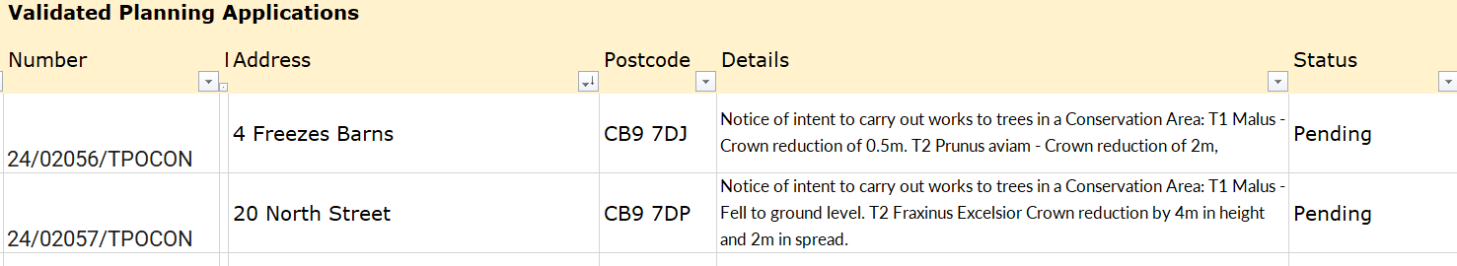

TPO’s are not commented on by

**Decisions**

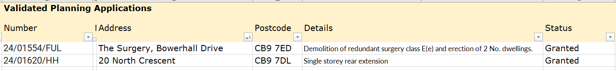

**24/139 Neighbourhood development plan,** to receive an update **Information**

Awaiting approval from BDC. Due to go to referendum next, dates not yet advised. Cllr Borges will call a

steering meeting soon. Chair Cllr Barnes will apply for additional grant funding.

**24/140 Financial Matters To note and Decision**

**Item 1.** To note receipts and approve upcoming payments **Decision**

RESOLVEDproposed by Cllr Hexter and seconded by Cllr Lacey.

**Item 2.** Bank reconciliation due – the second quarter reconciliation was passed to Cllr Hill to review.

**24/141 Admin Information & Decision**

**Item 1. Landscapes Tender** – update and timescale –



ITT packs have been sent to current and interested parties, plus it is on the portal. Submission deadline is 31/10/24

Last date for questions is 20/10 and these will be published on the PC’s website.

**Item 2**. **gov email addresses** - Decision on change of accounts

The clerk has received some quotes and put forward a quote for a .gov domain, new website and .gov email accounts, with clerk as admin controller for £385 (with an additional £100 discount available) this is with Parish Online who are well respected by Council authorities, and is actually less than the PC currently spends with WIX.

Videos and information was sent to the full council to review and raise questions on prior to the meeting.

Cllr Swaby is concerned about cyber security and has a quote for security and email hosting only. The clerk has been unable to verify the company’s details. The PC decided they needed more information before proceeding.

Given the renewal dates of WIX products starting on 14th October (as per finance report) the clerk advised that a decision on whether to renew these was needed. The PC then made the decision to cancel ALL WIX products, against the advice of the clerk.

RESOLVED Proposed by Cllr Lacey, seconded by Cllr Rust. **Decision**

*Update: following the meeting the clerk cancelled the renewal of all WIX products. After seeking advice and approval from the Finance Working Group, using delegated powers the clerk renewed the domain and both email accounts. The website is still set to expire, however there is over a month left on this so it will move to November’s agenda.*

**Item 3**. .**gov website domain change** – consideration of moving to .gov website. Agreed that clerk

may move on to a .gov domain, will attempt to obtain grant.

**Item 4**. **New Facebook page** – now in place, however on hold until the old FB account has been

looked at again. *Update: prior to publication of minutes: new FB is to be used, Chair Cllr Barnes and Cllr Hexter have access to place posts. Clerk has admin control.*

**Item 5**. **Grants** - update on applications and grant reports, Incl. Ninja trail

Following the PC meeting in September the Clerk applied for 2 Community Garden grants and awaits response.

Clerk has been in touch with Jack Hubbard who works with PC’s to obtain grant funding for a new piece of play equipment, he suggested a Ninja trail, which is a more modern trim trail and would be a good replacement for our deteriorating trim trail. The PC agrees this is a good opportunity, but would like to know at what point we are committed, what is the timeframe and are there any costs to the PC. Clerk will instruct him to write a grant RESOLVED application and see if we can get this all in for free – funded by a national lottery grant.

**24/142 Churchyard Wall –** update on recent progress **Decision**

Laser scan done of the wall; they will produce some CAD scans. Invoice expected for this in line with quote.

Next stage is to organise a meeting with the architect.

**24/143 Events**

**Item 1. Biennial community day / Bumpstead day** – Cllr Mackenzie suggested that the village have a bi-annual event just for the community, a Bumpstead day or Carnival day, a brief suggested plan is for the first event to take place next year on the Bank Holiday weekend of Saturday August 23rd 2025 on the Camping Close an all-day event, starting with a football game, then car show & stalls and games etc going on to an evening event too. Funds could be raised for a particular target or village projects. If agreed with, an article in YB with first meeting of volunteers for January 25.

RESOLVED

**Item 2. Christmas Event update** – update on progress. Incl. Advent Windows **Decision**

Cllr Lacey gave an update, all actions are on target, mini stalls will be in the Moot Hall again. Advent

windows are already getting booked.

**24/144 S106 funds –** an update on progress with regard to this sporting spend **Information**

Following recent meetings, it was agreed that the clerk and Cllr Rust will draw up a specification to provide to some contractors to prepare a quote. This is to be done. Cllr Hexter is going to put up a couple of posts to gauge interest in setting up pétanque or table tennis leagues / teams.

**24/145 Open Spaces Working group update** – to share status updates on all areas. **Information**

**Item 1. Open Spaces** update – no further update

**Item 2. *In*Bloom** – Bulb Planting – 2500 daffodils were planted on Sunday 5th October, we are very

grateful to the volunteers and for Cllr Hexter arranging this all.

**Item 3**. **Footpaths** update – The finger post by Lowerhouse is down, another down by Garlands farm,

then at broad green a fingerpost is missing, awaiting an update on the diversion. Opposite bowls club, the slats to the bridge have been replaced.

**Item 4. Herb Planter** –The Beavers group are planting and managing the seasonal planter.

**Item 5. Brook Management** – from Sept meeting, reported to Environment Agency and awaiting updates. The path down to the bridge on Church Street was cleared of brambles by Cllr Lacey.

**O T H E R I T E M S F O R D I S C U S S I O N**

**24/146 Remembrance Day Parade** – on Sunday 10th November. Silent soldiers and clay and knitted poppies to go out soon. Cllr Westrope will clean and tidy up the memorial and is liaising with the vicar regarding the service timings.

**24/147 Bell ropes Fence / gate / hedge** – update re: safety of the preschoolers using the area, landowner and Chair will be progressing this with a temporary fence while the hedge grows.

The SB Environmental group has re-dug and seeded the wildflower area at bell ropes, they have also put up a dead hedge. Grass has been removed and appears to be in the water ways, it will need to be moved – Cllr Mackenzie is in contact with them and will provide updates to the PC and OSWG.

**24/148 Information Sharing** – Cllr Westrope – none, Cllr Borges – none, Cllr Swaby - none, Cllr Hill - none, Cllr Lacey - none, Cllr Hexter - none, Cllr Rust – the VH committee met and agreed a full refurbishment of the village hall, Cllr Mackenzie – none, Chair – Community Solar energy open day in Whites Colne, invitation to be shared for anyone who is interested. MOP has reported street light faults on Blois Road, not sure which lights are faulty Cllr Hill to check and advise.

**24/149 Meeting Close & Date of Next meeting** – 14th November. Meeting closed at 22.02

**Signed by Chairman ……………………**

**Date …………………………………………….**

