**Members of the Council are hereby summoned to attend the**

**STEEPLE BUMPSTEAD PARISH COUNCIL Meeting @ The Moot Hall**

**ON Thursday 9th January 2025 at 7.30pm for the purpose of transacting the following business.**

**Members of the press and public are welcome to attend.**

3rd January 2025

Julia Howard, Clerk to Steeple Bumpstead Parish Council

**A G E N D A**

**25/001 Welcome and to receive apologies for absence Chairman**

**25/002 Declarations of Interest Information**

To declare any Disclosable Pecuniary, Pecuniary or non-Pecuniary Interest relating to items on the agenda

**25/003 To approve the minutes** (previously circulated) **Decision**

of the Parish Council meeting held on 12th December 2024.

**25/004 Question Time** **Information**

Public Participation Session with respect to items on the agenda and other matters of mutual interest. Please note: The maximum time allowed for this item is 15 minutes but may be extended at the discretion of the Chairman

**25/005 Invitation to Cllr Peter Schwier, Essex County Council and Information**

**Cllr Diana Garrod, Braintree District Council** to address the meeting on matters of mutual interest.

**25/006 New hedge planted by Bellropes/Tanyard** – an update on the progress of the donated hedge  **Information**

**25/007 Anglian water road closures** – an update on the local closures and works **Information**

**25/008 Planning**

**Applications**

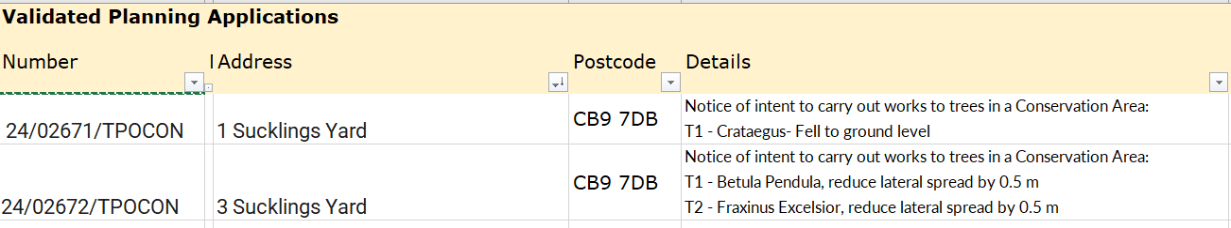

**Decisions**



**25/009 Neighbourhood development plan,** to receive an update **Information**

**25/010 Financial Matters To note and Decisions**

**Item 1.** To note receipts and approve upcoming payments

**Item 2.** To approve the proposed budget for 2025/26

**Item 3.** To agree the precept figure for 2025/26

**25/011 Admin Information & Decision**

**Item 1. gov email addresses, website and cyber-security** - Decision on change of accounts

**Item 2**. **Clerks report –** an update on previous delegated actions

**Item 3**. **Grants** - update on applications and grant reports, incl. s106

**25/012 Closed Item – To agree clerk’s hourly rate and pension** – this item is closed to the press & public (who may return afterwards) **Decision**

**25/013 War Memorial –** consideration of remedial works required **Decision**

**25/014 Flood Initiatives Group** – update as we come into the wet season again **Information**

**25/015 Open Spaces Working group update** – to share status updates on all areas. **Information**

**25/016 Events** – update on recent and forthcoming events (Christmas Tree, Village Showcase, Biennial Bumpstead Day **Decision**

**O T H E R I T E M S F O R D I S C U S S I O N**

**25/017 Yellow Book deadline** – 17th January 25

**25/018 Information Sharing**

**25/019 Meeting Close & Date of Next meeting** – 13th February